Alice480 Web Application

System Requirement Specifications

©2013 Mercer University

Revisions

| Version | Primary Author(s) | Description of Version | Date Completed |
| --- | --- | --- | --- |
| 1 | Paul Mould |  | 12/13/13 |

# Introduction

## Purpose

This document provides all of the requirements for the Alice480 Web application. Parts 1 and 2 are intended primarily for users of the application, but will also be of interest to software engineers, but will also be of interest to users.

## Scope

This document covers the requirements for release 1.0 Alice480. Mention will be made through this document of selected probable features of future releases. He purpose of this is to guide developers in selecting a design that will be able to accommodate the full-scale application.

## Definitions, Acronyms, and Abbreviations

See Table 1.

Table 1Definitions, Acronyms, and Abbreviations

|  |  |
| --- | --- |
| User | a generic user/everyone. A basic user has the lowest set of permissions, the are only allowed to enter and compete in a contest. |
| Sponsor | someone who heads a team of users, can be teacher, dean, etc. must be affiliated with an institution or organization |
| Contest Organizer | Someone who has the permission to create a contest. They have the ability to set how many members per team. And who is able to join the contest, which is enforced by limiting who receives sponsor codes. |
| Sponsor codes | A sponsor code is a code of N alphanumeric characters that is associated with a particular contest. The code is used to sign up for a contest. A member will enter the code in the contest registration page to register for the contest. |
| Active Contest | All contests being run.  Everyone’s front page |
| Entered Contests | All contests in which a contestant are a part of.  Everyone/contestant |
| Created Contests | Contests create by a specified owner.  Sponsor/owner |
| Contests Management | Contests management by a user.  Sponsor/managers/Owner |
| Completed Contest | Ended contests. Everyone maybe be more detailed for participant. |
| Alice480 | The short form of the Alice 480 web application, Alice Programming Contest Site. |
|  |  |
|  |  |
|  |  |

# Overall Description

Alice480 is a system designed to host programming competitions. The system allows for a extensive number of users. Users are categorized by the User Groups that they are associated with. Each group has their own permissions setting. In order for the system to work there has to be an administrator user, contest creator user, Judge User, Team member user, Sponsor User. Administrators have all permissions therefore they can perform all tasks. In the system the administrator is responsible for administering user groups, add users to groups and approve sponsors. A contest creator is allowed to create a contest. A Sponsor is associated with a contest. Team members can only join a contest that there sponsor is associated with. Team members upload their problem solutions to the server. The judge has privileges to grade the solution. There is a scoreboard for each contest that is automatically updated as contests are graded.

## Product Perspective

### Concepts of Operation

* Log In: the state in which the user logs into the system
* Administrator: the system gives access to pages for administrator’s permissions.
* Contest Creator: the system gives access for contest creators
* Hold a Contest: the state of hosting a live contest on the system
* Judge: the system gives access to pages for Judges to grade submissions
* Grading: the state at which judge is grading submissions
* Team Member: the system gives access to pages for members of contest teams
* Submissions: a Team submits a problem to the database
* Scoreboard: the system displays the scoreboard for a contest

### 

### User Interfaces

All the user interfaces are specified in detail in section 3.

### 

Figure Figure 1 Use Case Diagram for the actual system

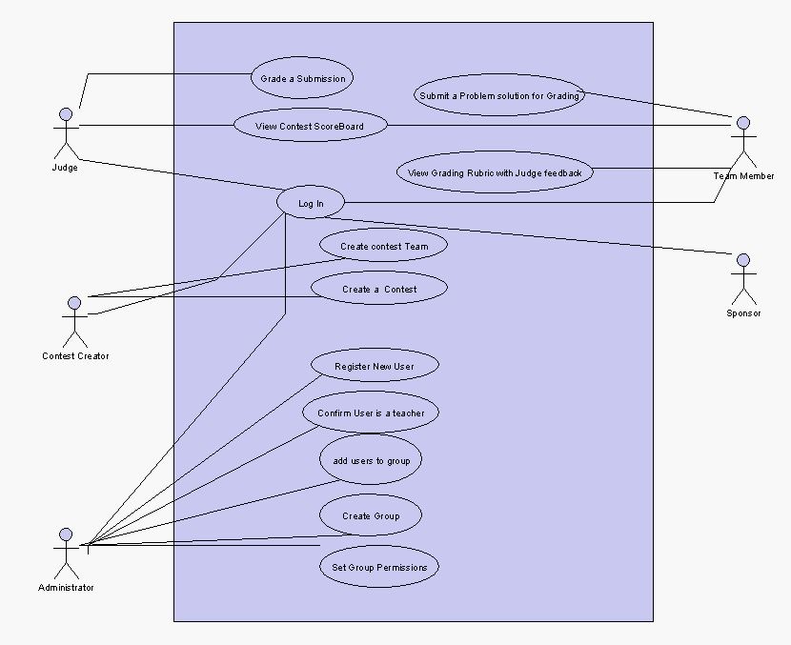

Figure Use Case Diagram showing sample users

### Lamp Stack Model

The system requires the use of a dynamic linux server to host the database and website. The Lamp stack comprises of the following:

* Linux
* Apache
* MySQL
  + The database is going to be made of several tables created using SQL
* PHP
  + The website pages are dynamic PHP pages

### Software Interfaces

None.

### Communications Interfaces

None.

### Memory Constraints

The memory constraints to host the website are limited to the amount of available memory space on the system server. The recommended server space would be 4GB of Memory. The website should not require more than 64PM of RAM to run.

### Operations

### See Section 3 for detailed information on the User Interfaces and Operations Memory Constraints.

### Site Adaptation Requirements

None

## Product Functions

### “Login” Use Case

Actor: Any user of Alice480

Use Case:

1. User enters username and password
2. System determines whether or not the password
3. If the password is valid the member home page is loaded
4. If the password is invalid an error message would appear under the password field and the user would be able to retry and log in with a correct password.

### “Sponsor Confirmation” Use Case

Actor: Administrator

Use Case:

1. User opens Approve sponsors page.
2. User checks the box of sponsors that they want to be approved
3. Clicks Submit Button

### Administer Groups Use Cases

* + - 1. **“Add Users to Group” Use Case**

Actor: Administrator

Use Case:

1. User select Group that you want to add users to
2. User enters User ID of users to be added to group
3. The User clicks submit
4. The system uploads the information to the server
   * + 1. **“Create Group” Use Case**

Actor: Administrator

Use Case:

1. Administrator enters the name of the group
2. Administrator clicks create group button
3. The system uploads the information to the server
   * + 1. **“Set Group Permissions” Use Case**

Actor: Administrator

Use Case:

1. Administrator selects the group to change submissions
2. Administrator checks the permissions that the group can have
3. Administrator clicks the “Set” button
4. The system uploads the information to the server.

### Create a contest Use Cases

* + - 1. **“Create Contest Entry” Use Case**

Actor: User with contest creating privileges

Use Case:

1. User enters the following fields
   * 1. Contest Title
     2. Contest Description
     3. Start Date
     4. Max Number of Teams
     5. Max Number of Teammates
     6. Max Number of Problems
     7. Max Number of Final Submission
2. User clicks the “Submit for Approval” button
   * + 1. **“Create Contest Rubric” Use Case**

Actor: User with contest creating privileges

Use Case:

1. Enter number of criteria
2. The system loads the criteria max points and description boxes
3. The user enters the max points and description in the boxes
4. The user clicks the “Create” button
5. The system updates the rubric for the Problem in the database Server
   * + 1. **“Create Contest Team” Use Case**

Actor: user

Use Case:

1. The user enters the names of the users for the Team
2. The user clicks the “Add a Contest Team” button
3. The system uploads the information to the server.

### “Submit a Contest Solution Use Case”

Actor: Team Member

Use Case 1 (precondition: Maximum files have not been uploaded):

1. On a Contest Problem Page click the user clicks upload contest
2. The system opens a Windows Browser
3. User selects file to upload and clicks Open
4. The file gets uploaded to the database server.

Use Case 2 (precondition: Maximum files have been uploaded):

1. On a Contest Problem Page click the user clicks upload contest
2. The system outputs a dialog box error message “Cannot submit problem solution. Maximum uploads have been reached.”

### “Download Contest Solution Use Case”

Actor: Grader

Use Case:

1. On a Contest Problem Page user clicks upload contest
2. Windows Browser opens up . User selects file destination to save file
3. User clicks Save button in Windows Browser
4. The browser is saved at the destination selected by the user

### “View Score Board Use Case”

Actor: Administrator

Use Case:

1. On the home page the user clicks the link to a Contest Scoreboard
2. System redirects to the Contest Scoreboard page

## User Characteristics

* + 1. **Sponsors**

Sponsors are high school teachers who wish to enter their students into programming competitions

* + 1. **Team Members**

They are high school students with a basic understanding of programming concepts.

* + 1. **Contest Creator**

Educators who wish to host a programming contest

* + 1. **Judge**

A judge is an educator who has qualifications to teach programming at a high school level

## Constraints

Alice480 would require a web browser to access the web application. The web application works with the following web browsers:

* Internet Explorer
* Mozilla FireFox
* Opera
* Google Chrome
* Safari

## Assumptions & Dependencies

None.

## Apportioning Requirements

None.

## Assumptions and Dependencies

None.

## Apportioning of Requirements

None

# Specific Requirements

## External Interface Requirements

## Specific Requirements

* + 1. Sequence Diagrams
       1. Login Use Case

This sequence Diagram for this use case is show in in Appendix A, Page A-2. This use case requires the Users Groups Page and the User Group Table.

* + - 1. “Add Users to Group” Use Case

This sequence Diagram for this use case is shown in Appendix A, Page A-3. This use case requires Users Group Page and the User Group Table.

* + - 1. “Create Group” Use Case

This sequence Diagram for this use case is shown in Appendix A, Page A-4This use case diagram requires the Create Group Page and the Database Server.

* + - 1. “Set Group Permissions” Use Case

This sequence Diagram for this use case is shown in Appendix A, Page A-5. This use case diagram requires the Group management page and the database server.

* + - 1. “Create a contest Entry” Use Case

This sequence Diagram for this use case is shown in Appendix A, Page A-6. This use case requires the Contest Management Page and the Database Server.

* + - 1. “Create Contest Rubric” Use Case

This sequence Diagram for this use case is shown in Appendix A, Page A-7. This use case requires the “create Rubric page” and the database server.

* + - 1. “Create Contest Team” Use Case

This sequence Diagram for this use case is shown in Appendix A, Page A-8. This use case requires Create Contest Team Page and the database server.

* + - 1. “Grade Contest Entry” Use Case

This sequence Diagram for this use case is shown in Appendix A, Page A-9. This use case requires the Grade Entry Page and the database server.

* + - 1. Submit a Contest Solution Use Case”

This sequence Diagram for this use case is shown in Appendix A, Page A-10. This use case requires the Grade Entry Page and the database server.

* + - 1. ”Submit Contest Solution” Use Case

This sequence Diagram for this use case is shown in Appendix A, Page A-12. This use case requires the Contest Problem Page, Windows Browser Object and the database server.

* + - 1. “Download Contest Solution Use Case”

This sequence Diagram for this use case is shown in Appendix A, Page A-13. This use case requires the Grade Entry Page and the database server.

* + - 1. “View Score Board ” Use Case

This sequence Diagram for this use case is shown in Appendix A, Page A-This use case requires the Home Page, Score Board Page and the database server.

# Appendix A

**Login Use Case**

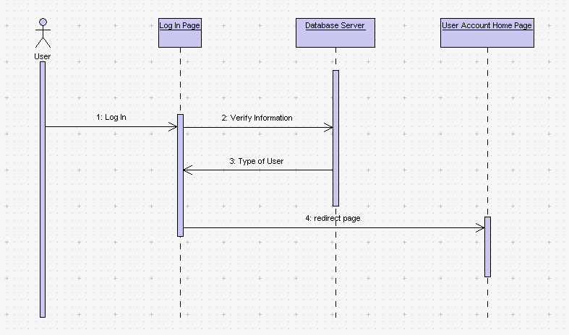

**“Add Users to Group” Use Case**

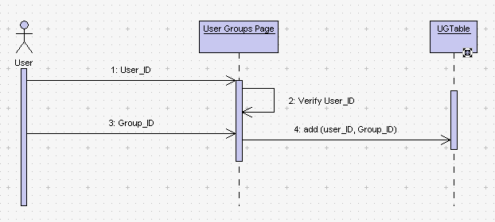

**“Create Group” Use Case**

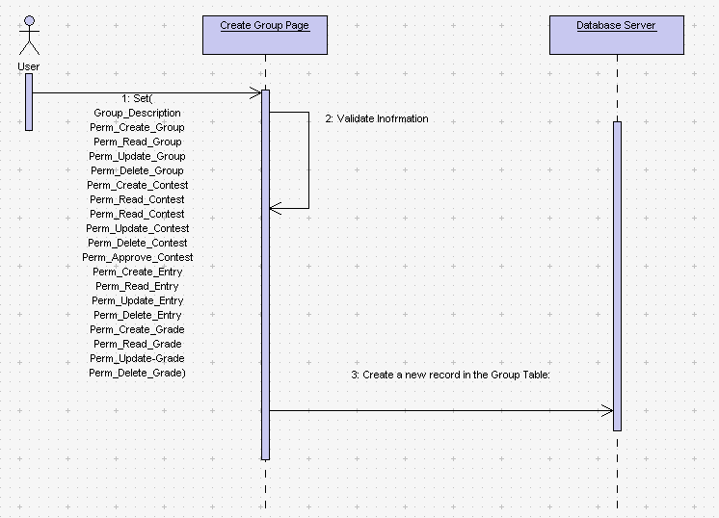

**“Set Group Permissions” Use Case**

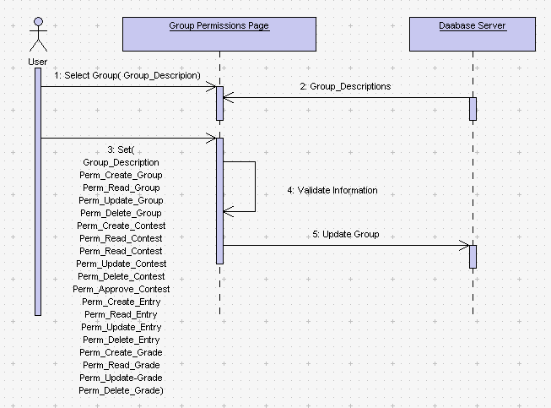

**“Create a contest Entry” Use Case**

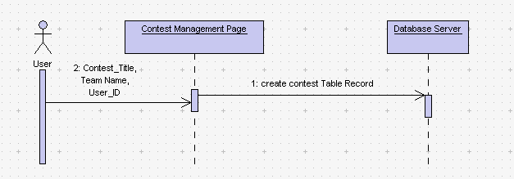

**“Create Contest Rubric” Use Case**

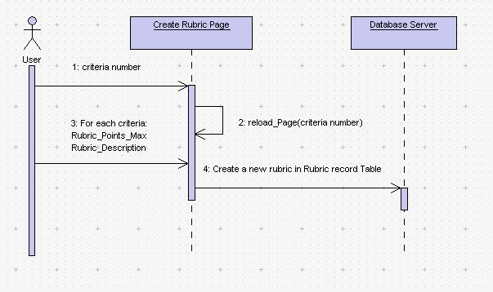

**“Create Contest Team” Use Case**

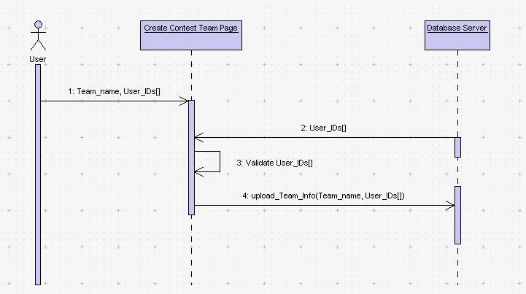

**“Grade Contest Entry” Use Case**

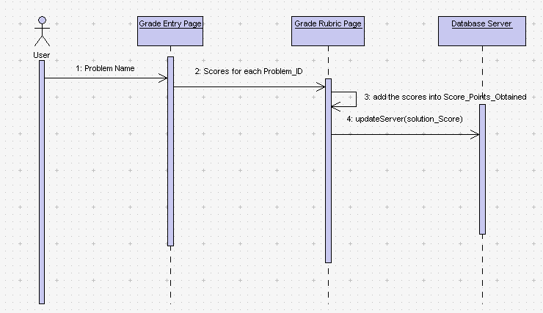

**“Submit a Contest Solution” Use Case**

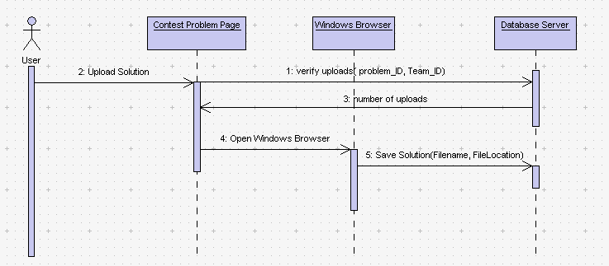

**“Submit Contest Solution” Use Case**



**“Download Contest Solution Use Case”**

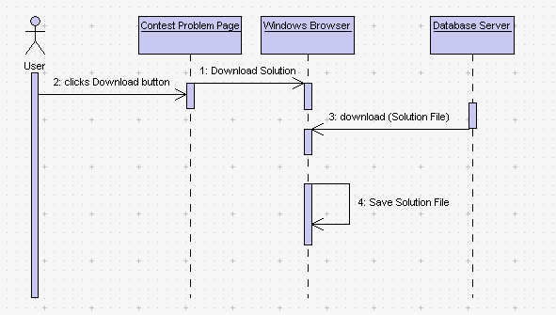

“**View Score Board” Use Case**

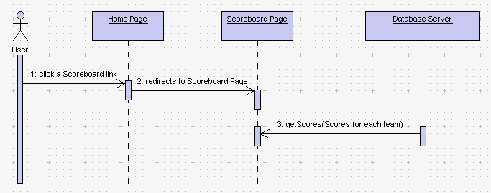

# Appendix B

**Screenshots**

**Contents**

Home Page of Alice480

Create Account Page of Alice480

Log In Page of Alice480

Permissions Group Creation Page of Alice480

(Top)

Permissions Group Creation Page of Alice480 (Bottom)

Manage Group Permissions Page of Alice480

Contest Creation Page of Alice480

**Home Page of Alice480**

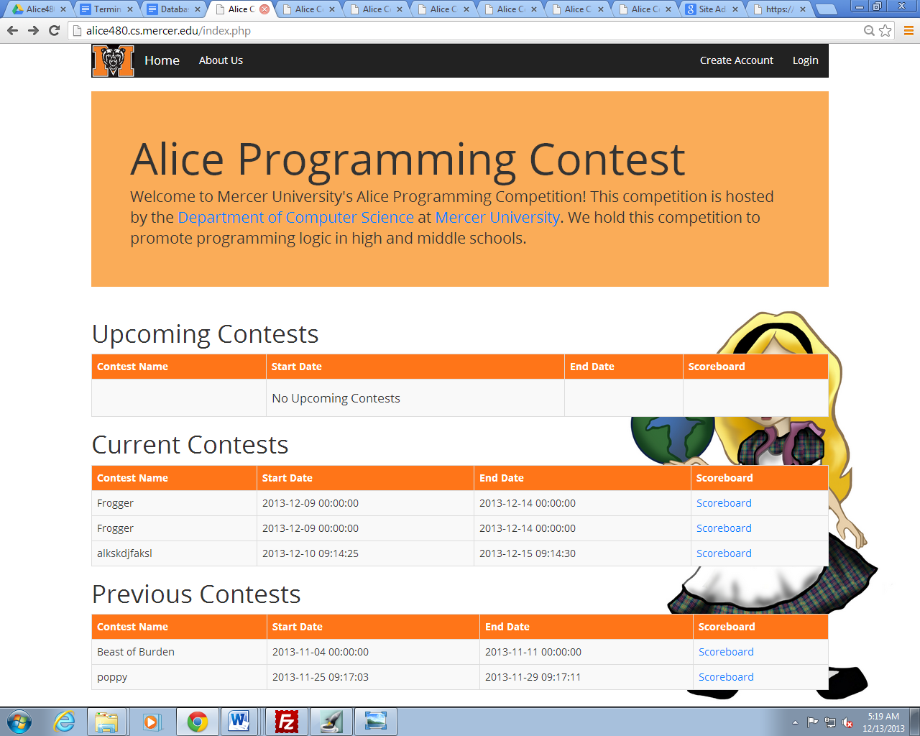

**Create Account Page of Alice480**

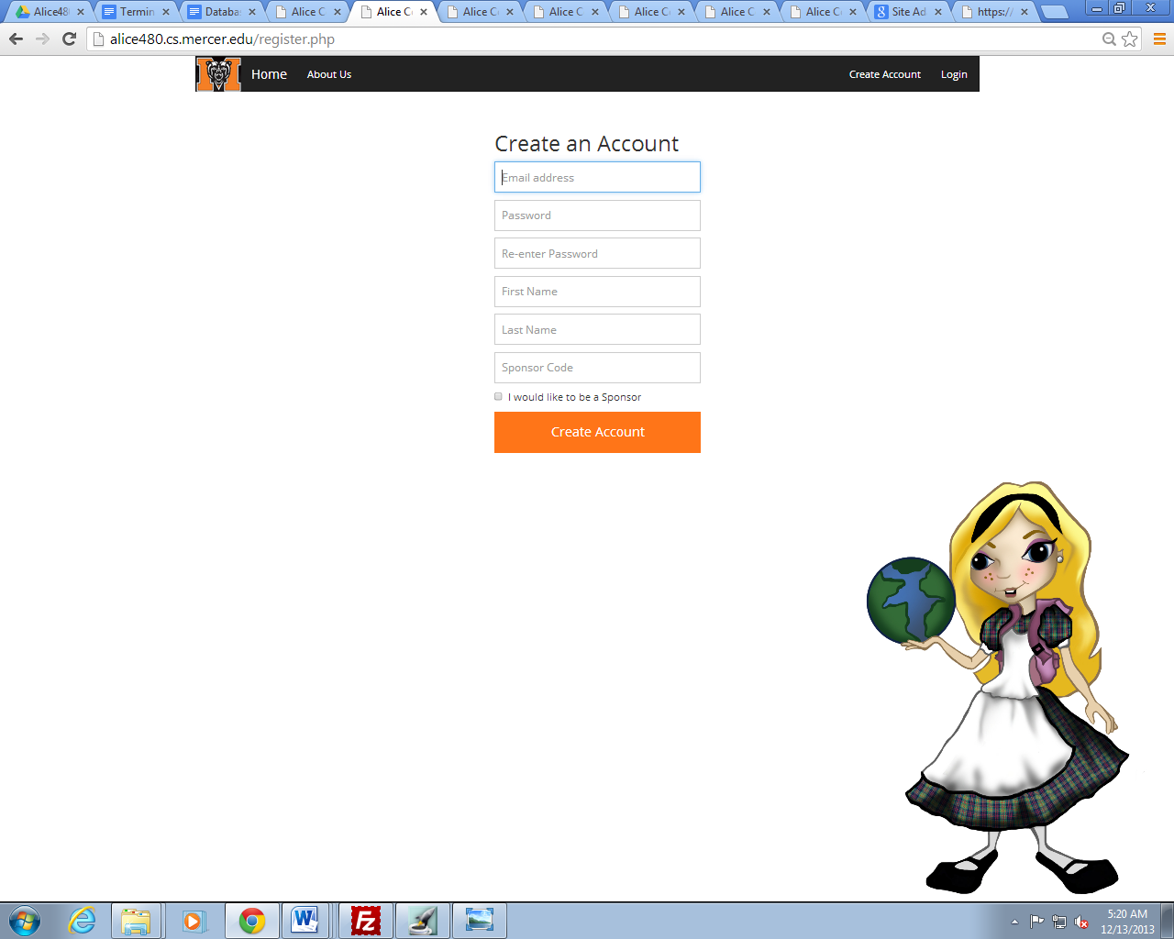

**Log In Page of Alice480**

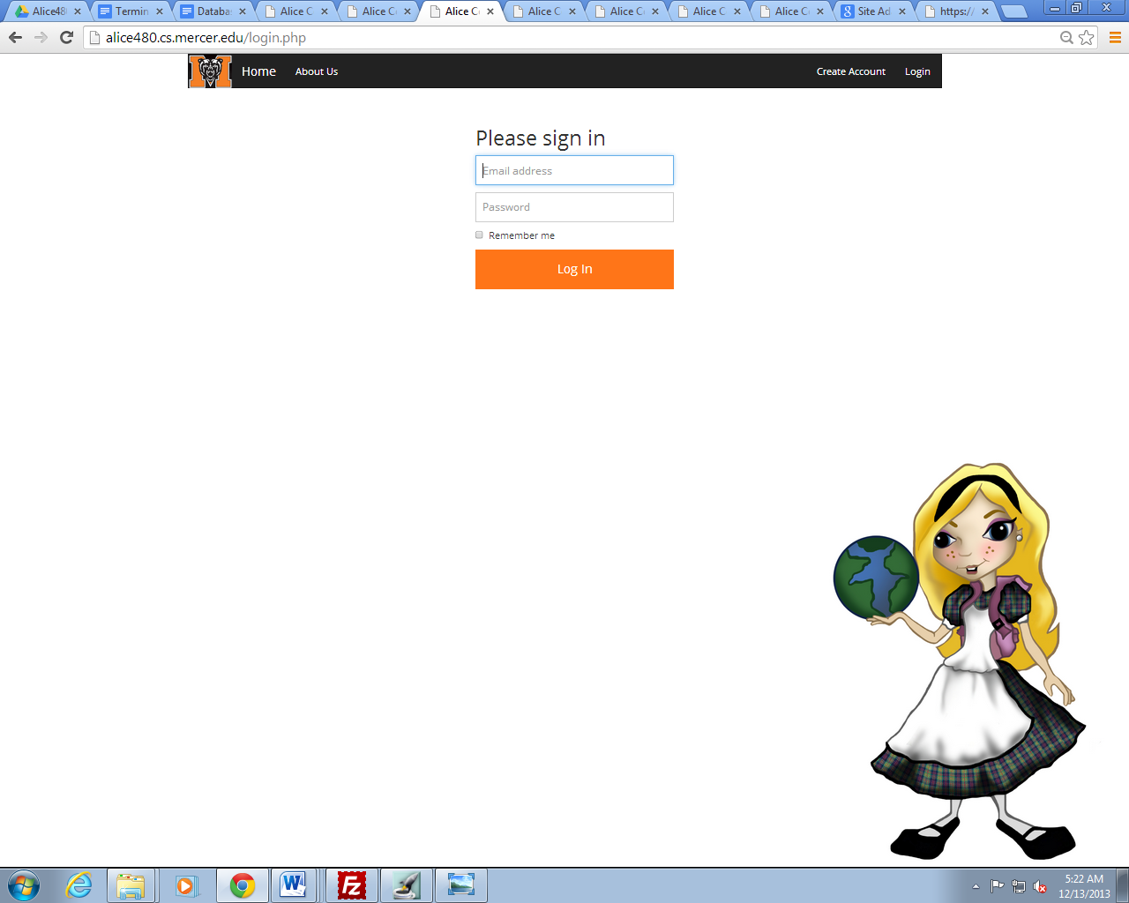

**Permissions Group Creation Page of Alice480**

**(Top)**

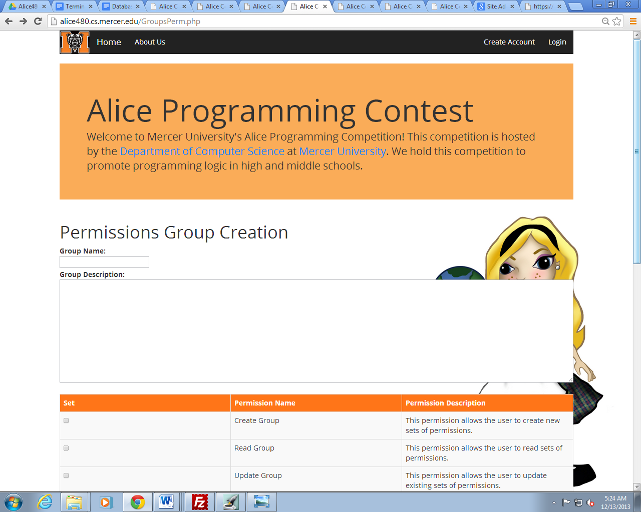

**Permissions Group Creation Page of Alice480 (Bottom)**

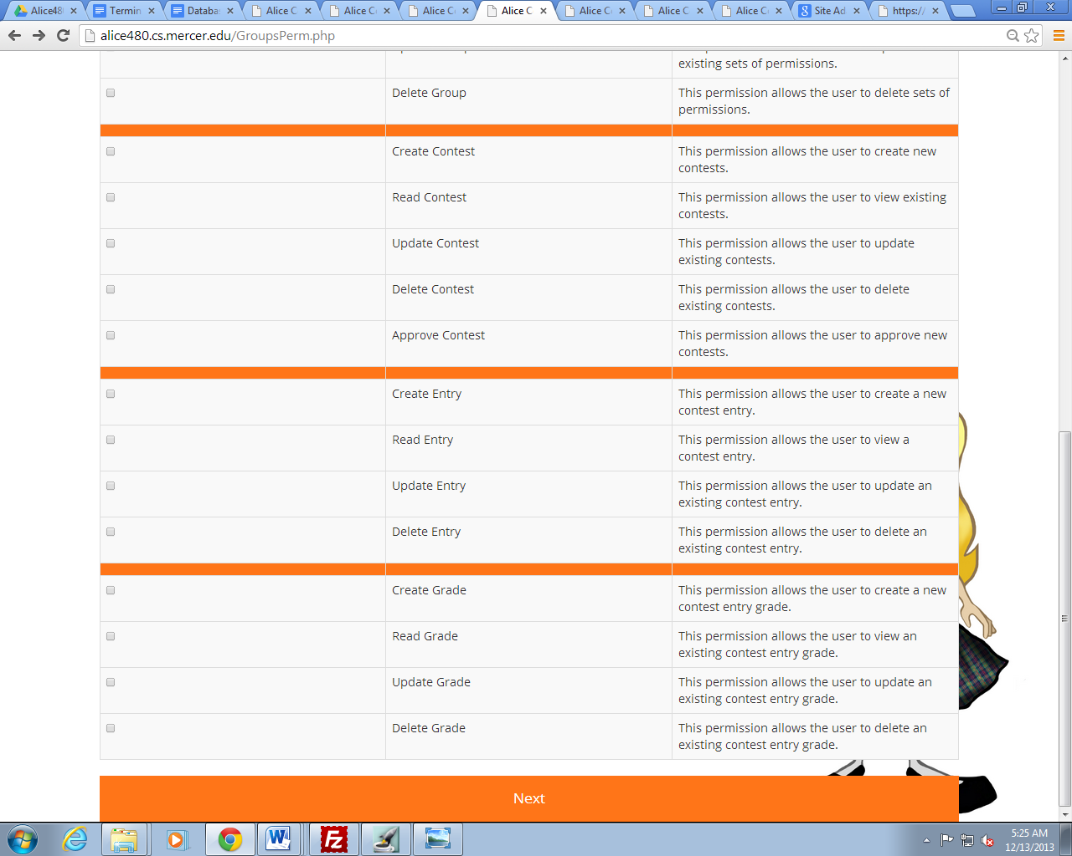

**Manage Group Permissions Page of Alice480**

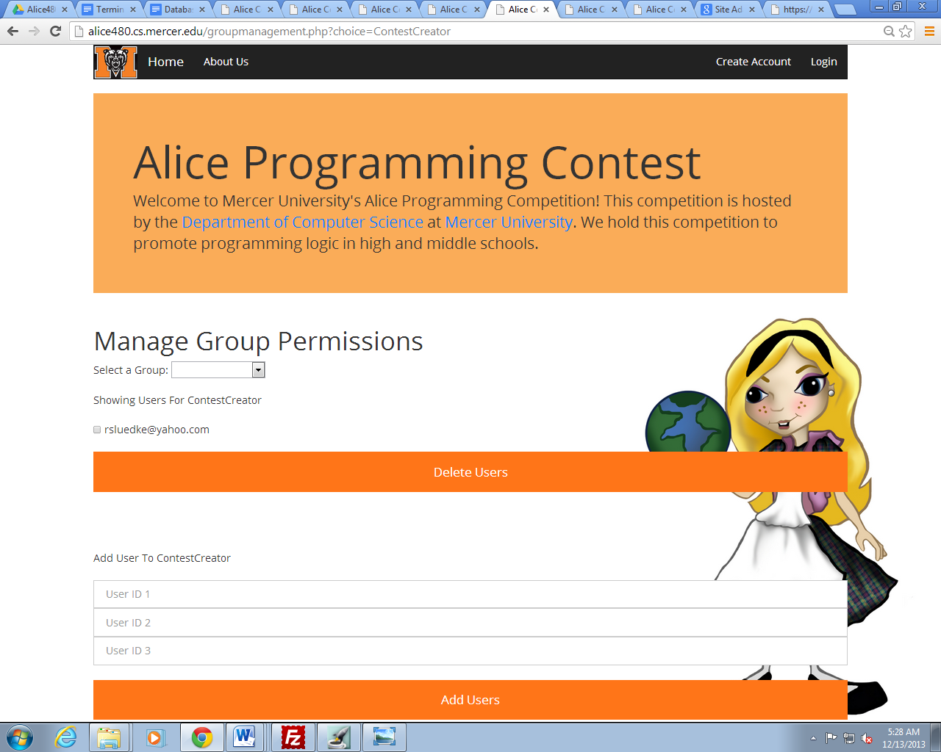

**Contest Creation Page of Alice480**

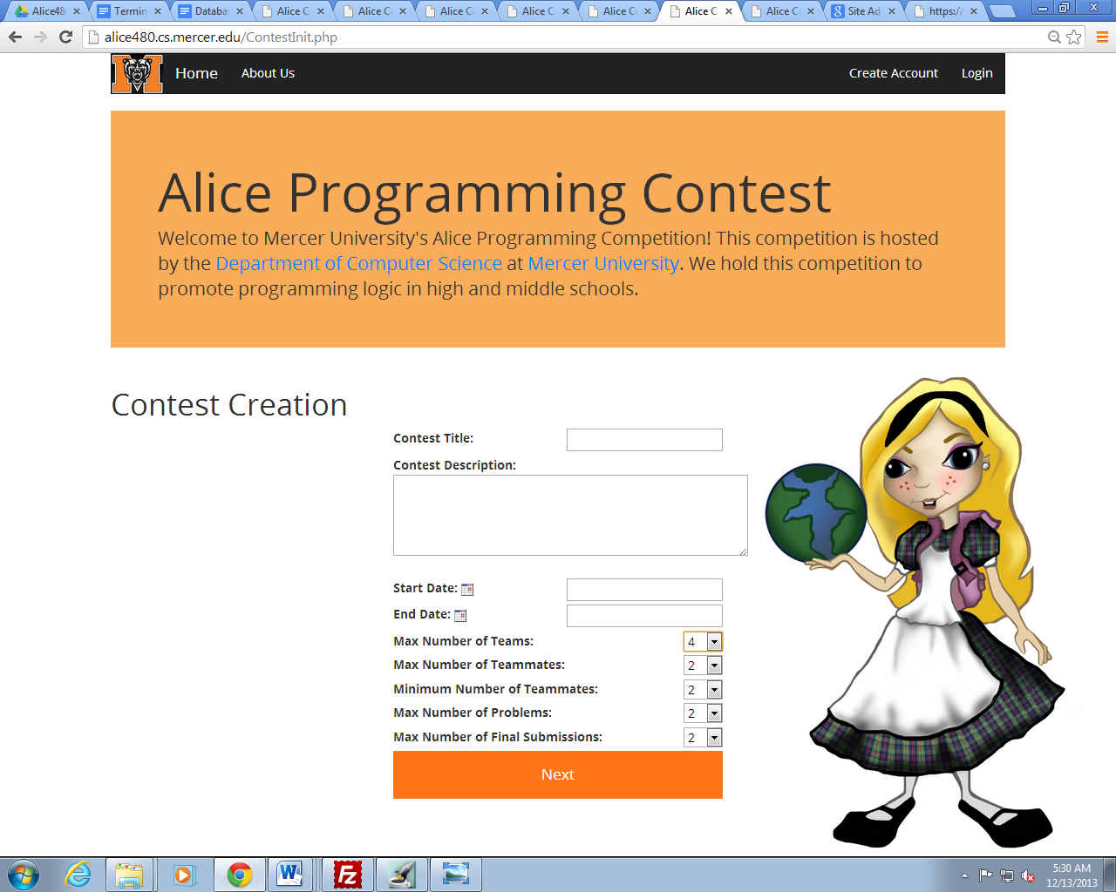

**Contest Problem Creation Page of Alice480**

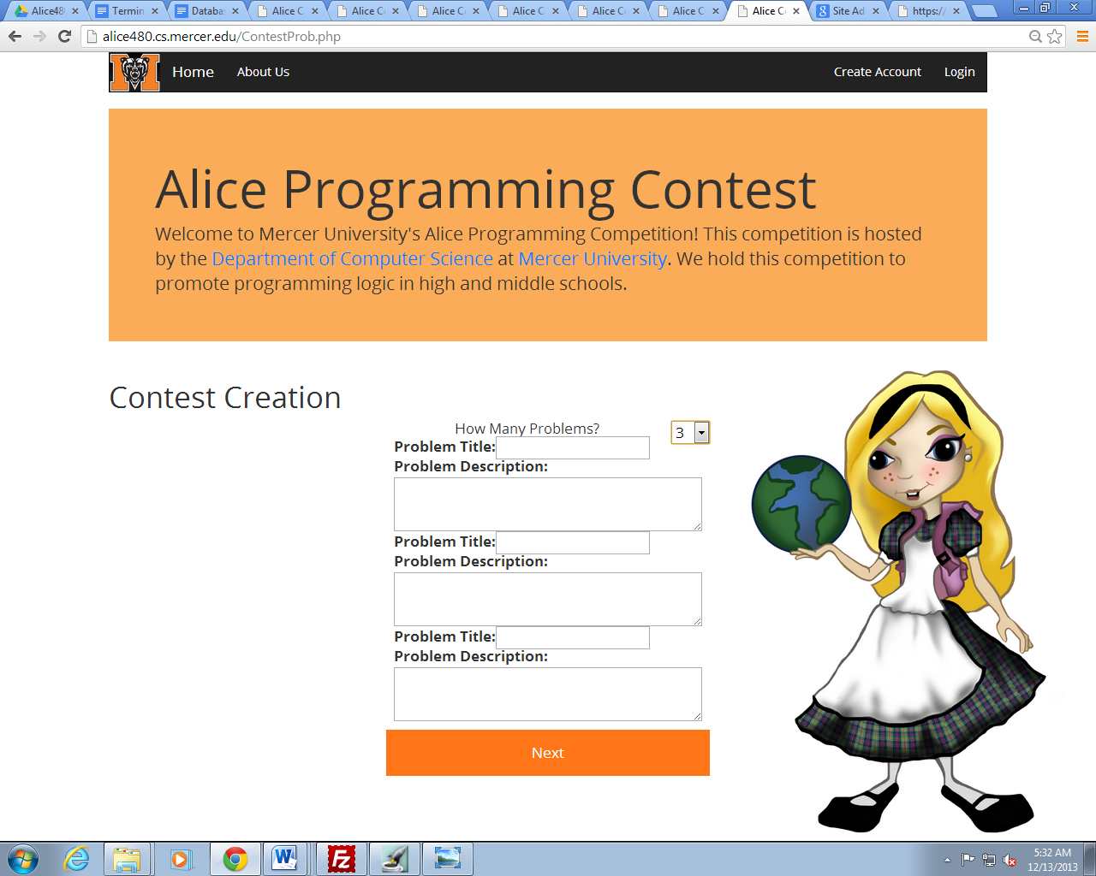

**Create Rubric Page of Alice480**

